CHIKKANNA GOVERNMENT ARTS COLLEGE
TIRUPUR-641602
(AFFILIATED TO BHARATHIAR UNIVERSITY)



1 . JOHN BRITO J – 2022K0025

2 . POOVARASAN S – 2022K0037

3 . PRAKASH B – 2022K0038

4 . PREM M – 2022K0039

5 . SYED OWAISE I – 2022K0057

DEPARTMENT OF COMPUTER SCIENCE

CHIKKANNA GOVERNMENT
ARTSCOLLEGE

NAAN MUDHALVAN PROJECT WORK

(AFFILIATED TO BHARATHIAR UNIVERSITY)
TIRUPUR-641602

TITLE : Intelligent Admissions The Future Of University
This is to certify that this is a bonafide record of work done by the above students of III B.Sc (CS) Degree NAAN MUDHALVAN PROJECT during the year ……….

Submitted for the Naan Mudhalvan project work held
on………….20

CLASS TUTOR HEAD OF THE DEPARTMENT

INDEX
S.No. | Date | Contents | Page No.
1 |  | PROBLEM SELECTION
2 |  | IDEATION
3 |  | REQUIREMENT ANALYSIS
4 |  | PROJECT DESIGN
5 |  | PROJECT PALNNING PHASE
6 |  | PROJECT DEVELOPMENT PHASE
7 |  | RESULT(INPUT & OUTPUT)

PROBLEM SELECTION

1. Predictive power: The problem should be able to accurately predict the success of the student in the university. This can be measured by looking at historical data and comparing the predicted outcomes with the actual outcomes.
2. Data availability: The problem should have a sufficient amount of data available for training the model. This includes data on the student's academic performance, extracurricular activities, and other relevant factors
3. Fairness: The problem should not discriminate against any particular group of students. This means that the data used should be representative of the entire population and the model should be designed to be unbiased
4. Predicting academic success: This problem involves predicting a student's academic performance in the university based on their past academic records, test scores, and other relevant factors
5. Identifying potential leaders: This problem involves identifying students who have demonstrated leadership potential in their past academic and extracurricular activities, and are likely to become effective leaders in the university

IDEATION

1. Personalized Admissions Process: Use machine learning to personalize the admissions process for each applicant, based on their unique strengths and weaknesses. This could include customized application questions, tailored interview questions, and targeted marketing materials
2.AI-Enabled Application Review: Use artificial intelligence to automatically analyze and evaluate student applications. AI could help to streamline the review process, allowing admissions officers to focus on the most promising candidates
3. Predictive Analytics: Develop algorithms that can predict which students are most likely to succeed at the university based on a variety of data points, such as academic performance, extracurricular activities, and personal background. This could help admissions officers identify promising students who might otherwise be overlooked.
4. Virtual Campus Tours: Develop virtual reality technology that allows prospective students to take a virtual tour of the campus. This could help to attract students who might not be able to visit in person, and provide a more immersive experience for all applicants.
5. Natural Language Processing: Develop algorithms that can analyze the content and tone of student essays and application materials, to identify any potential issues or concerns. This could help to ensure that students are able to communicate effectively and appropriately in their written materials
REQUIREMENTS ANANLYSIS

1. Natural Language Processing: Develop algorithms that can analyze the content and tone of student essays and application materials, to identify any potential issues or concerns. This could help to ensure that students are able to communicate effectively and appropriately in their written materials
2. Automated Interviews: Develop chatbots or other automated interview tools that can ask applicants a series of standardized questions, and analyze their responses. This could help to provide a consistent and fair interview process for all applicants
3. Data-Driven Decision Making: Use data analysis and machine learning to help admissions officers make more informed decisions. This could include predictive modeling, simulations, and other tools to help evaluate the potential outcomes of different admission decisions
4. Student Profile: Understanding the types of students who will be seeking admission to the future university, their academic backgrounds, and their interests and goals will help determine the types of intelligent admission tools and techniques that will be needed
5. Admission Criteria: Determining the criteria that the future university will use to admit students, such as standardized test scores, GPA, extracurricular activities, and personal essays, will be important in determining what types of intelligent admission tools will be necessary

6. Data Collection: Identifying the data that will be collected on prospective students, such as demographic information, academic history, and personal interests, will be essential to develop intelligent admission models
7. Analytics and Modeling: The development of analytics and modeling techniques that can be used to predict a student's likelihood of success at the future university will be crucial to developing intelligent admission tools
8. Data Integration: Integration of various data sources such as past student performance, student demographic data, and admission criteria for creating predictive models
9. Data Privacy: Ensuring the privacy of student data collected and stored as well as maintaining ethical and legal standards regarding data management and analysis
10. User Experience: Developing an intuitive and user-friendly interface for students to interact with the intelligent admission system
11. Scalability: Designing a system that can handle the expected volume of data and the increasing number of applicants in the future

PROJECT DESIGN
1. Identify the admission criteria: Determine the factors that will be considered for admission to the university, such as academic qualifications, extracurricular activities, personal statement, recommendation
2. Gather data: Collect data on previous admission cycles, including applications, admissions, and demographics of admitted students. This data will be used to train the AI model
3. Select an AI model: Choose the appropriate AI model for the admission system, such as a decision tree, a neural network, or a random forest model
4. Prepare the data: Clean and preprocess the data to ensure that it is accurate, complete, and consistent. This may involve removing duplicates, filling in missing values, and transforming data into a suitable format for the AI model.
5. Train the model: Use the prepared data to train the AI model using a suitable algorithm. The model should be optimized for accuracy, precision, and recall.
6. Integrate the model into the admission process: Once the model has been tested and validated, integrate it into the admission process. This may involve creating a user interface for admissions officers to interact with the model, or automating the decision-making process entirely
7. Monitor and update the model: Continuously monitor the performance of the AI model and update it as needed. This may involve collecting feedback from admissions officers or retraining the model with new data
PROJECT PALNNING PHASE

1. Define the project scope: The first step would be to define the project scope and objectives. This would involve identifying the requirements of the university and understanding the current admission process
2. Assemble a team: Next, a project team would need to be assembled. The team would include individuals from various departments such as admissions, IT, and finance. It would be important to assign clear roles and responsibilities to each team member.
3Define the system requirements: The project team would then need to define the system requirements. This would involve identifying the data that needs to be collected, the type of analysis that needs to be performed, and the features that the system should have..
4. Identify the technology stack: Once the system requirements are defined, the team would need to identify the technology stack that would be used to build the system. This would involve selecting the programming language, database, and other technologies required
5. Develop a project plan: With the system requirements and technology stack identified, the team can develop a project plan. This would involve creating a timeline, defining milestones, and estimating the resources required.
6. Develop a proof of concept: Before starting development, it would be advisable to develop a proof of concept. This would involve building a small-scale version of the system to test the feasibility of the technology stack and system requirements.
7. Build the system: Once the proof of concept is successful, the team can begin building the full-scale system. This would involve designing the system architecture, building the database, developing the application code, and testing the system.
8. Deploy the system: After the system is built and tested, it can be deployed to the production environment. This would involve configuring the system on the production servers, setting up the necessary security measures, and training the staff on how to use the system
9. Monitor and maintain the system: Once the system is deployed, it would be important to monitor and maintain it. This would involve monitoring the system performance, fixing any bugs or issues that arise, and making updates and improvements as necessary
10. Evaluate the success of the system: Finally, it would be important to evaluate the success of the system. This would involve collecting feedback from the users, analyzing the system performance, and making any necessary adjustments to improve the system's performance and user experience.

PROJECT DEVELOPMENT PHASE

1. Requirements gathering: In this phase, you need to gather all the requirements for the intelligent admission system. You can do this by interviewing university administrators, admission officers, and students, as well as by conducting surveys and research to determine what features and functionalities the system should have.
2. System design: Based on the requirements gathered in the previous phase, you need to design the system. This includes defining the system architecture, identifying the technologies to be used, and creating detailed specifications.
3.System design: Based on the requirements gathered in the previous phase, you need to design the system. This includes defining the system architecture, identifying the technologies to be used, and creating detailed specifications.
4.Development: In this phase, you need to build the system. This includes coding, testing, and debugging the software, as well as designing the hardware components of the system.
5. Integration: Once the system components have been developed, they need to be integrated into a cohesive system. This includes testing the integrated system to ensure that all components work together seamlessly.
6. Deployment: After testing the system, it needs to be deployed. This means installing the hardware and software components, configuring the system, and training the staff to use it.

7.Maintenance: Once the system is deployed, it needs to be maintained. This includes monitoring the system for bugs and issues, fixing any problems that arise, and updating the system to keep up with changes in technology and user needs.

8. Natural Language Processing: Develop algorithms that can analyze the content and tone of student essays and application materials, to identify any potential issues or concerns. This could help to ensure that students are able to communicate effectively and appropriately in their written materials.
9. Automated Interviews: Develop chatbots or other automated interview tools that can ask applicants a series of standardized questions, and analyze their responses. This could help to provide a consistent and fair interview process for all applicants.
10. Data-Driven Decision Making: Use data analysis and machine learning to help admissions officers make more informed decisions. This could include predictive modeling, simulations, and other tools to help evaluate the potential outcomes of different admission decisions.

CODING

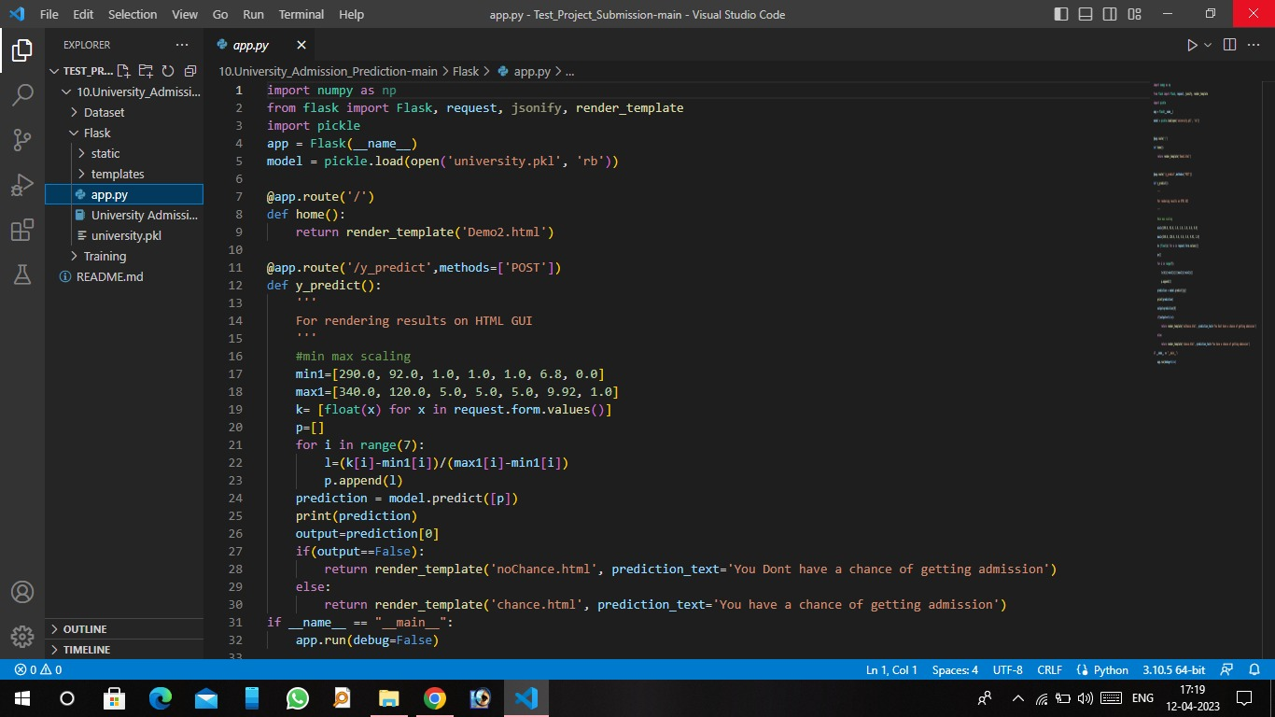

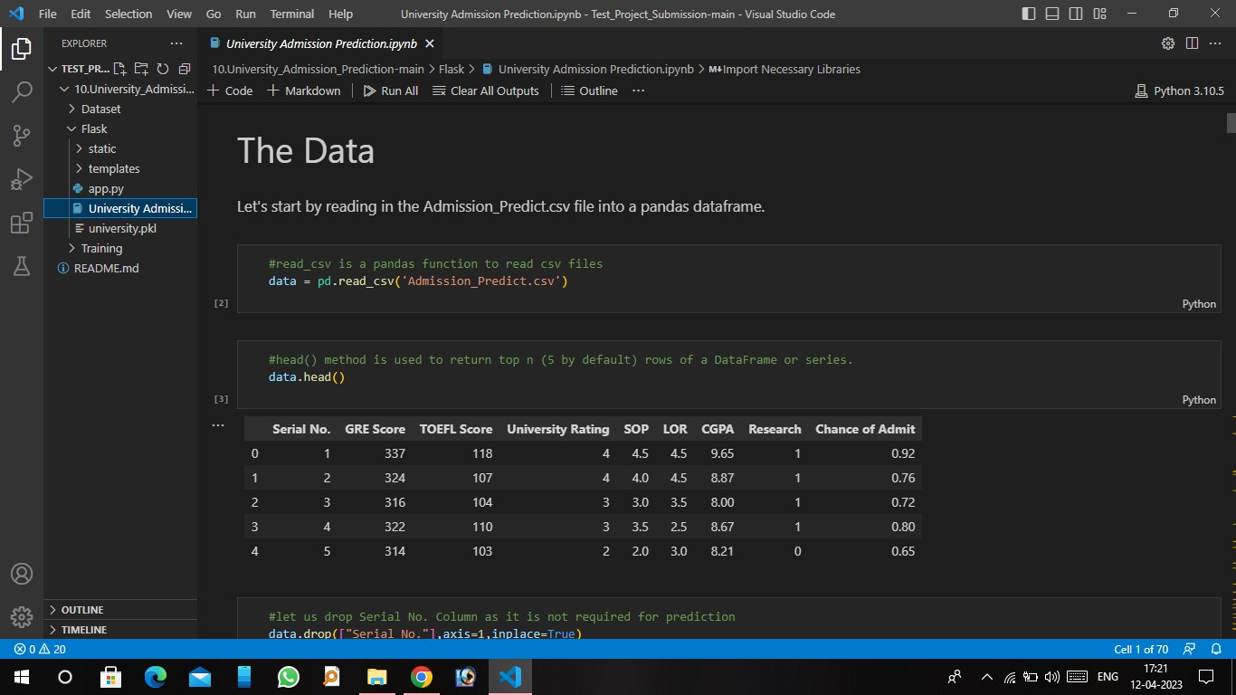
OUTPUT

